**Whitewater Rafting Website Project Planning Document**

**1. Logo**  
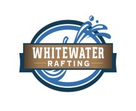

**2. Color Palette**

* **primary-color:** #2A1A1F
* **secondary-color:** #B7B6C1
* **accent1-color:** #000000
* **accent2-color:** #5A6650

**Color Palettes link:**  
https://coolors.co/000000-2a1a1f-b7b6c1-5a6650

**3. Fonts**

* **heading-font:** Montserrat
* **text-font:** Nunito Sans